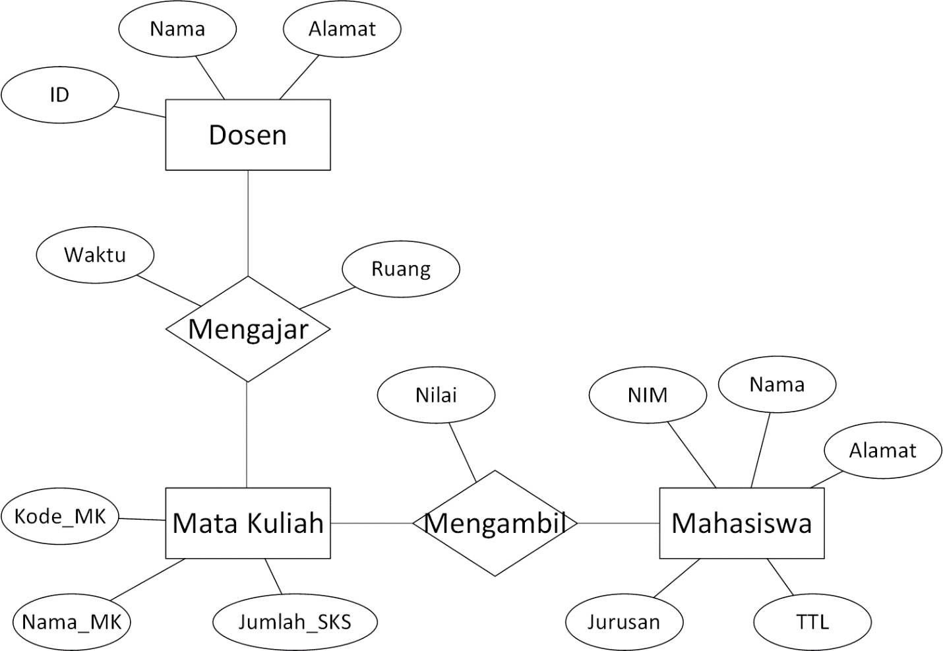

**TABEL**

|  |  |  |  |  |  |  |  |
| --- | --- | --- | --- | --- | --- | --- | --- |
| Tabel Dosen | | | | |  | |  |
|  |  |  |  | |  | |  |
| ID | Nama | Alamat |  |  | |
|  |  |  |  |  | |
|  |  |  |  |  | |
|  |  |  |  | |  | |  |
| Tabel Mengajar | | | | |  | |  |
|  |  |  |  | |  | |  |
| ID | Kd_mk | waktu | ruang | |  | |  |
|  |  |  |  | |  | |  |
|  |  |  |  | |  | |  |
|  |  |  |  | |  | |  |
| Tabel MK | | |  | |  | |  |
|  |  |  |  | |  | |  |
| Kd_mk | Nama MK | Jumlah SKS |  | |  | |  |
|  |  |  |  | |  | |  |
|  |  |  |  | |  | |  |
|  |  |  |  | |  | |  |
| Tabel Mengambil | | |  | |  | |  |
|  |  |  |  | |  | |  |
| NIM | Kd_mk | nilai |  | |  | |  |
|  |  |  |  | |  | |  |
|  |  |  |  | |  | |  |
|  |  |  |  | |  | |  |
| Tabel Mahasiswa | | | | | | |  |
|  |  |  |  | |  | |  |
| Nim | Nama | Alamat | TTL | | Jurusan | |  |
|  |  |  |  | |  | |  |
|  |  |  |  | |  | |  |
|  |  |  |  | |  | |  |

**TRANSLATION**



Pembagian Tugas per modul

Thomas Yanuar Nogroho :

Sekar Mirah :

Elisabeth Kusuma Adi :